Step 1: Type Y for yes or N for no When the program prompts you (“Would you like to add an item”)

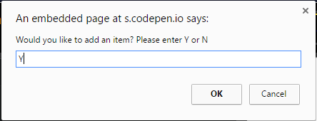

Step 2: Enter your item name and price with the following syntax candy, 20 | If you would like to stop adding additional items to your cart please enter -1

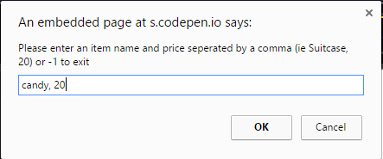

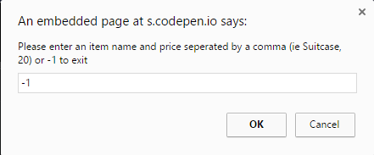

Step 3: If you would like to remove all of an item in your cart type Y on the prompt (“Would you like to remove all of an item?”) otherwise type N.

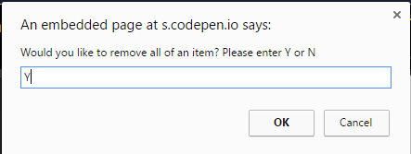

Step 4: Enter the name of the item you would like to remove from your cart on the prompt (“Please enter the name of the item you would like to remove.”) 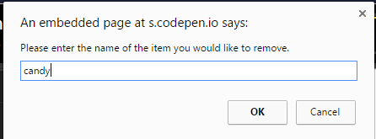

Step 4: If you would like to alter the quantity of an item in your cart type Y on the prompt (“Would you like to change quantity of an item?”) otherwise type N

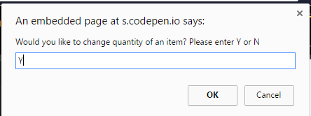

Step 5: Enter the name of the item who’s quantity you want to change on the prompt (“Please enter the name of the item whose quantity you would like to change.”)

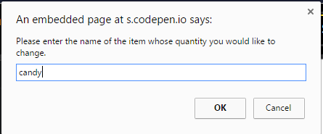

Step 6: Enter the amount you would like to change the item’s quantity to on the prompt (“Please enter the name of the item whose quantity you would like to change.”)

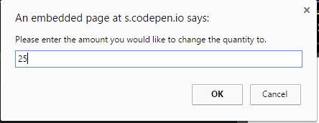

Steps repeat until you decide you don’t want to add any more items.